Laparoscopic Assisted Insertion of Thecoperitoneal Shunt, Simple Technique in a Single Institution. Experience and Comparison with Traditional Mini-laparotomy.

Mohammed Hammad Eltantawy ¹, MD, Ashraf El- Desouky ², MD, Ahmed Nawar³, MD,
Ahmed Abdel Hafeez ⁴, MD,
Neurosurgery Department, Benha University^{1,2,4}, General surgery Department, Benha University³
Abstract
Background: Thecoperitoneal shunts are the gold standard surgical treatment of Idiopathic Intracranial hypertension after failure of conservative treatment. Many complications were encountered with traditional minilaparotomy incision for distal shunt placement specially in obese patients. We described our laparoscopic technique for distal shunt placement and compared our results with the minilaparotomy.
Methods: 20 patients prospectively were operated for IIH by laparoscopic technique from May 2017 to June 2019, and retrospectively we compared another 20 patients who were operated with the minilaparotomy technique from June 2015 to August 2017 in our institution. Data were collected regarding age, weight, abdominal circumference, history of previous abdominal surgery, postoperative complications, time of surgery, blood loss, need for repeated revisions, hospital stay, and patient satisfaction. Data were analyzed for comparison between the two groups and P-value was considered significant if<0.05.
Results: The mean time of surgery in the laparoscopic group was (45.5 ± 12.4 minutes) compared to (95.6 ±15.5 minutes) in the mini laparotomy group. Blood loss was significantly lower in laparoscopic group (P-value=0.004). Mean postoperative hospital stay was 1.12±0.47 days in laparoscopy group compared to 2.35±1.52 days in the other group (P-value<0.00001). Overall postoperative complications were significantly lower in laparoscopic group with much better patient satisfaction.
Conclusion: Laparoscopic assisted technique for inserting the abdominal end of the thecoperitoneal shunt is safe, effective and easy procedure. It has many advantages over the traditional minilaparotomy technique, with much less complication rate. Its importance is obvious in morbidly obese patients and patients with previous abdominal surgeries.
Keywords: Thecoperitoneal shunt, Laparoscopic assisted, Mini-laparotomy, Idiopathic Intracranial Hypertension
Correspondence to, Mohammed Hammad Eltantawy, Department of Neurosurgery, Benha University;
Email: hammad_neurosurg@yahoo.com Egypt Tel.; 01000221379

Introduction
Thecoperitoneal or lumboperitoneal shunts are considered the gold standard tool in management of Idiopathic Intracranial Hypertension, after failure of medical treatment and repeated lumber punctures, for the fear of rapid visual deterioration. [1]
The minilaparotomy incision has been used traditionally for intraperitoneal placement of the abdominal end of the shunt. Many complications have been encountered from this technique due to the fact that this disease is usually encountered in obese women and that the surgery is done in the lateral position that make the insertion of the distant end technically difficult and need large incision. Some of these complications were extra peritoneal location of the tube, slippage of the abdominal tube, incisional hernia formation at surgery site, intra-abdominal adhesions, subcutaneous seroma and infection, disconnection and cosmetic disfigurement. [2,3,4]
With advancing minimally invasive laparoscopic techniques this surgery become much easier with much less complications. [5] Early reports were encouraging [5,6,7]. Using the laparoscope in placement of the abdominal end of the LP shunt offered many advantages over the classic minilaparotomy, it should avoid large scars in the abdominal wall, ensure proper position of the abdominal end of the shunt away from adhesions and omentum specially in patients with multiple previous abdominal surgeries. [8]
Using the laparoscope in this surgery also decreased the operative time, postoperative abdominal pain and provided a chance for dissecting the adhesions in patients with previous abdominal surgeries. [5]
Introducing the catheter from the subcutaneous tissue to the peritoneal cavity through puncture without abdominal incision and with short subcutaneous track; prevent the potential withdrawal of the catheter into subcutaneous bucket decreasing the need for multiple abdominal revisions of the shunt. [9]
Several studies described laparoscopic assistance of inserting VP shunts in supine position [9,10,11]. We found only few reports of using the laparoscope in LP shunts in lateral decubitus. [5,8,12,13]

Methods
In this study we operated on 20 patients suffering from idiopathic intracranial hypertension with LP shunts, (in whom medical treatment and repeated lumber punctures failed to control their condition), using laparoscopic assisted technique for insertion of the abdominal end of the shunt. Data were collected regarding age, weight, abdominal circumference, history of previous abdominal surgeries, post -operative complications, time of surgery, blood loss, need for repeated revisions of the LP shunt, hospital stay and patient satisfaction after surgery. Those patients were operated in the period between May 2017 till June 2019 and followed from six months to one year. Retrospective review was conducted on another 20 patients operated in our Institute for treatment of idiopathic intracranial hypertension between June 2015 and August 2017, and followed from six months to two years, who had LP shunts insertion with the traditional mini laparotomy approach in placement of intraperitoneal catheter. Data were collected for the same parameters as the laparoscopic group and the results were statistically analyzed.
All patients were operated in our Institute by neurosurgeon only in the traditional mini laparotomy group, and by teamwork of neurosurgeon and general surgeon in the laparoscopic group. In all patients we used the one -piece CSF - lumbo-peritoneal catheter system, 84 centimeters Medtronic, Inc USA
Surgical technique
After induction of general anesthesia, patient is positioned in lateral decubitus with left side up in most cases, and occasional right side up in case of extensive abdominal scars in the left side, with the knees and hips partially flexed to open the interspinous space. The axilla is protected by silicone pad with the lower arm stretched and the upper arm put over arm sling cranially away from the chest and abdomen (Figure 1).
Fig (1) The patient is positioned in lateral decubitus with left side up with the knees and hips partially flexed to open the interspinous space, with the lower arm stretched and the upper arm slinged over arm sling cranially away from the chest and abdomen.

Sterilization and draping are made exposing the midline of the back opposite L3 -4 and L4 -5 interspinous spaces and abdomen exposing the umbilicus as a landmark. Both the neurosurgeon and the laparoscopist can start work simultaneously. Pneumoperitoneum is done by using Veress needle with the goal of reaching 15 mm Hg of CO2 insufflation pressure. The site of puncture of the needle is usually made at Palmer Point in the left upper quadrant, 3 centimeters below the costal margin in the mid clavicular line, unless this access is determined by prior surgical procedures. Then 10 -millimeter camera port is inserted in the mid clavicular line at the level of the umbilicus (Figure 2) through which the scope is introduced and the abdominal cavity is inspected for intraperitoneal adhesions at the upper paracolic gutter (Figure 3).

Fig (2) 10-millimeter camera port is inserted in the mid clavicular line at the level of the umbilicus through which the scope is introduced and the abdominal cavity is inspected, then 5 -millimeter working channel trocar is inserted midway between mid-clavicular line and the midline about 10 centimeters away from the umbilicus in cranial direction and is used to introduce the non-traumatic grasper to pull the LP shunt.

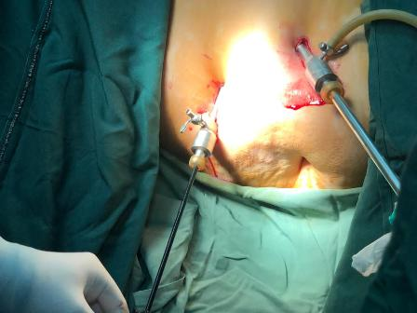

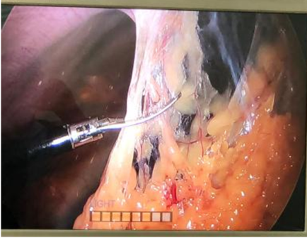
Fig (3) The abdominal cavity is inspected for intraperitoneal adhesions at the upper paracolic gutter and adhesiolysis is made.

The first 5 -millimeter working channel trocar is inserted under Laparoscopic visualization midway between mid -clavicular line and the midline about 10 centimeters away from the umbilicus in cranial direction (Figure 2). This working channel is used to introduce the non - traumatic grasper to pull the LP shunt. The position of the second 5 millimeter working trocar is made in the posterior axillary line opposite the lumbar incision and confirmed to be in the paracolic gutter under laparoscopic visualization (Figure 4 A and B).

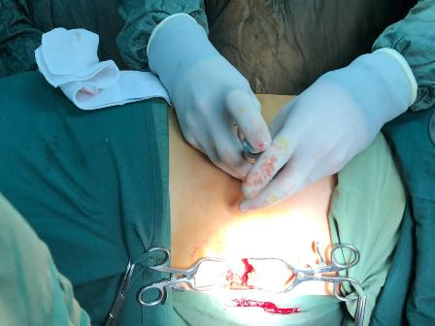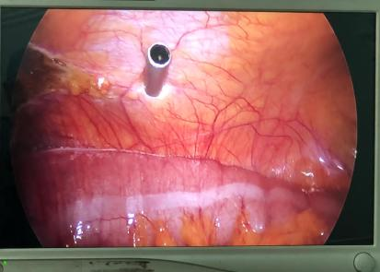
4A
4B

Fig (4) The position of the second 5 millimeter working trocar is made in the posterior axillary line opposite the lumbar incision (A), confirmed to be in the paracolic gutter under laparoscopic visualization (B).

A 5-centimeter midline lumbar incision is made opposite L3 and L4 spinous processes and dissection is made till reaching the lumber fascia. Identification of the interspinous space is confirmed by digital palpation. The Tuohy needle is introduced with the beveled edge directed up, till CSF flow is confirmed, and then the Tuohy needle is rotated 90 degrees so that the beveled edge is directed cranially and the LP shunt is introduced inside the intra dural space till the second marker on the shunt (Figure 5 A and B). The needle is then withdrawn carefully, and the position is confirmed by the CSF drops coming out of the shunt.

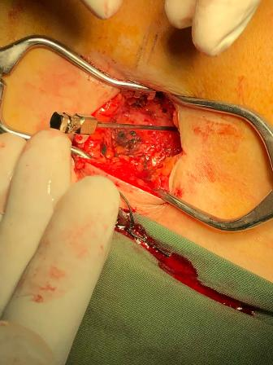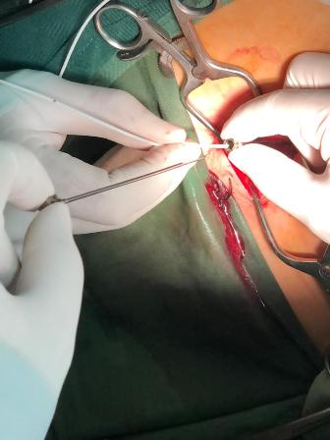
5A
5B

Fig (5) The Tuohy needle is introduced with the beveled edge directed up till CSF flow is confirmed and then rotated 90 degrees so that the beveled edge is directed cranially (A) and the LP shunt is introduced inside the intradural space till the last marker on the shunt (B).

A custom -made peel away sheath is designed from 18 F nelaton catheter that is cut longitudinally and introduced into the peritoneal cavity through the 2nd working channel and pulled inside by the aid of the grasper from the first working channel (Figure 6). Then the second working channel trocar is removed leaving the peel away sheath partially inside and partially outside the abdominal cavity.
6B
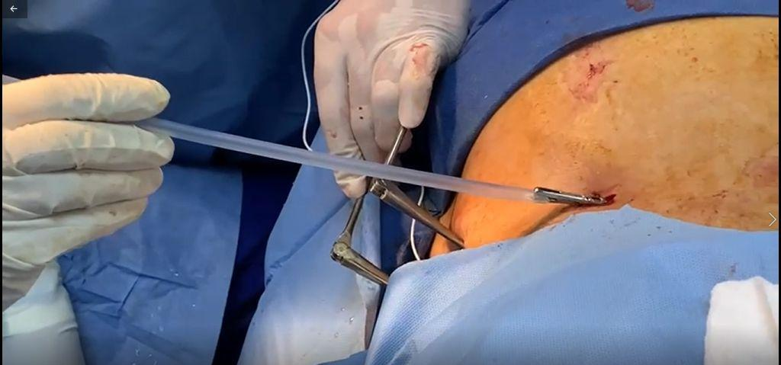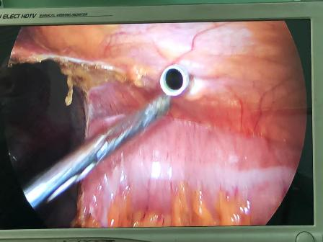
6A

Fig (6) custom-made peel away sheath introduced to the peritoneal cavity through the 2nd working channel (A) and pulled inside by the aid of the grasper from the first working channel (B).

Then the shunt passer is tunneled subcutaneously from the incision of the peel away sheath toward the lumbar incision (Figure 7 A) and the shunt is introduced through the passer then the passer is removed and the shunt is inserted through the peel away sheath (Figure 7 B) till it becomes visualized inside the peritoneal cavity and grasped by the non -traumatic grasper, then the peel away sheath can be removed leaving the shunt inside the abdominal cavity (Figure 8 A and B).

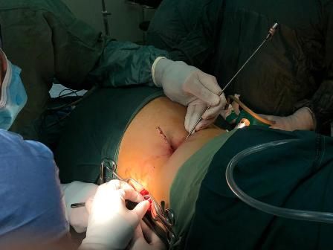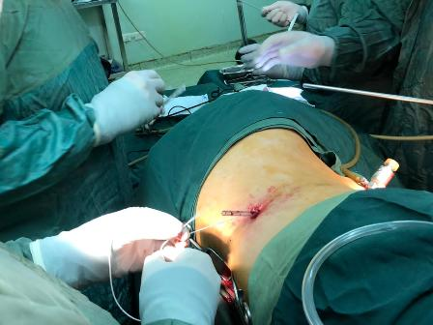
A
B

Fig (7) The shunt passer is tunneled subcutaneously from the incision of the peel away sheath toward the lumbar incision (A)and the shunt is introduced through the passer then the shunt is introduced through the peel away sheath (B).

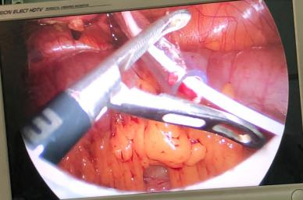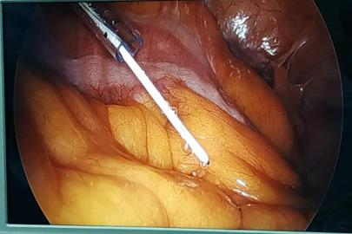
8A
8B

Fig (8) the shunt is visualized inside the peritoneal cavity and grasped by the non-traumatic grasper (A), then the peel away sheath can be removed leaving the shunt inside the abdominal cavity (B).

The CSF is confirmed again coming through the narrow slits of the LP shunt under laparoscopic visualization and placed mostly in left subphrenic space away from the omentum and any abdominal adhesions.

After deflating the abdominal cavity and removing the trocars, the incision made for the camera port is sutured while the other two abdominal incisions left without suturing. The lumber incision is sutured in a subcuticular fashion. (Figure 9 A and B)

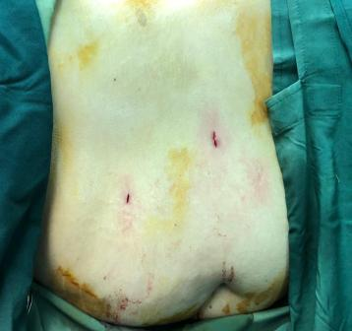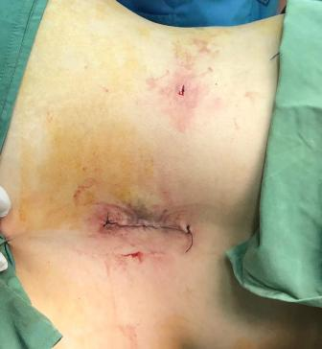
A
B

Fig (9) The incision made for the camera port is sutured while the other two abdominal incisions left without suturing (A). The lumber incision is sutured in subcuticular fashion (B).

Informed consent and ethics committee approval:
This study was given approval by the Research Ethics Committee (REC) of Neurosurgery Department, Faculty of medicine, Benha University on July 2017. All patients signed informed consent for the surgery after explaining surgical steps, benefits, and possible complications. All procedures performed involving human participants were in accordance with the ethical standards of the institutional and/or national research committee and with the 1964 Helsinki declaration and its later amendments or comparable ethical standards.
Statistical analysis:
Software (SPSS, Version 25.0 for Windows, Armonk, NY: IBM Corp.) was used for analysis of data. Qualitative variables were summarized as frequency and percentages while quantitative data as mean ±SD. Analytic statistics tests; Student’s test, Chi -square test, and Fisher exact test to assess the statistical significance and relationship for the qualitative variables. P -value < 0.05 is considered statistically significant at a confidence interval 95%.

Results

Demographic data and patient criteria in both groups are shown in table (1). The rate of previous abdominal operations is higher in the laparoscopic group.

Table 1: (patient Demographics)
criteria |  | Mini-laparotomy group | Laparoscopic group
Number of patients |  | 20 | 20
Mean age(year) |  | 32.15 ± 10.18 | 36.55 ± 7.60
Gender |  | M 3  F 17 | M 5  F 15
Mean weight (Kg) |  | 90.75 ± 12.68 | 95.25 ± 11.73
Mean Abdominal circumference (CM) |  | 121.2 ± 21.01 | 122.35 ± 19.34
Previous abdominal surgery | cesarean section | 3 | 6
 | Appendectomy | 2 | 5
 | Cholecystectomy | 1 | 1
 | Abdominal exploration | 0 | 1
 | Total | 6 patients | 13 patients
Mean follow up period(months) |  | (6-24) mean 15 | (6-12) mean 9

The mean time of surgery in the laparoscopic group was much lower (45.5 ± 12.4 minutes) compared to (95.6 ±15.5 minutes) in the mini laparotomy group which is statistically significant (P < 0.0001). The estimated blood loss was minimal in four patients (20%) compared to 13 patients (65%) in laparoscopic group and mini laparotomy group respectively, while no blood loss (< 10 CC) was observed in 16 patients (80%) in the laparoscope group compared to 7 (35%) in the mini laparotomy group (P value = 0.004) which is significantly lower in the laparoscopic group (See table 2).

Table 2:( Operative Data)
operative data |  | Mini-laparotomy  group | Laparoscopic group | p
Mean time of surgery(min) |  | 95.6 ± 15.5 | 45.5±12.4 | < .0001
Estimated blood loss | None  (<10CC) | 7 | 16 | 0.004
 | Minimal  (20-30 CC) | 13 | 4

The mean post -operative hospital stay was (1 .12 ±0. 47 days) in the laparoscopic group and that was significantly lower than the mini laparotomy group which was (2.35±1.52days) (See table 3)

Table 3: (post-operative Data)
post-operative data |  | Mini-laparotomy  group | Laparoscopic group | p
Mean post-operative stay (days) |  | 2.35 ± 1.52 | 1.12 ± 0.47 | < .00001
Complications | Subcutaneous slippage of peritoneal end | 4/20  (20%) | 0/20 | 0.005
 | Intraperitoneal cyst formation | 0/20 | 1/20  (5%)
 | Incisional hernia | 2/20  (10%) | 0/20
 | Abdominal wound infection | 2/20  (10%) | 0/20
 | Extra peritoneal position of abdominal tube | 1/20  (5%) | 0/20
 | Persistent abdominal distention and pain along shunt tract | 4/20  (20%) | 1/20  (5%)
 | Persistent papilledema after surgery | 2/20  (10%) | 1/20  (5%)
 | Need for repeated surgical revision | 7/20  (35%) | 1/20  (5%)

The rate of postoperative complications was much lower in the laparoscopic group; only one patient (5%) developed persistent abdominal distention and pain along the shunt track that was resolved by simple medications in few days. In the mini laparotomy group 2 patients (10%) developed abdominal wound infection and subcutaneous seroma due to subcutaneous dissection that necessitate surgical debridement of the wound. Both patients developed incisional hernia later on; one of them underwent surgical repair and the other was followed conservatively. Slippage of the peritoneal end was observed in four patients (20%) in the mini laparotomy group, all of them presented with localized abdominal collection that was diagnosed by the ultrasound to be subcutaneous CSF collection with peritoneal end coiled inside, the 4 patients underwent revision. In these four patients the part which was inserted inside the peritoneum was short due to morbid obesity that made no enough length left.
one patient (5%) in this group was discovered in the post -operative X Ray film to have the peritoneal end in the extraperitoneal space, which was mistakenly inserted again due to the morbid obesity and short tube
Four patients (20%) suffered from postoperative abdominal distention and abdominal pain in the mini-laparotomy group for four days after surgery. This is compared to 1 patient in the laparoscopy group. Two patients (10%) had persistent papilledema after surgery in the mini laparotomy group compared to only one patient (5%) in the laparoscopic group. All three patients had surgical revision
one patient in the laparoscopic group (5%) had intraperitoneal cyst formation that was noticed by postoperative ultrasound, had no effect on the improvement of the patient and did not need any revision.
seven patients (35%) in the mini laparotomy group needed repeat surgical revisions, two patients (10%) due to persistent papilledema, four patients (20%) due to subcutaneous slippage and one patient (5%) due to extra peritoneal position of the abdominal tube. This is compared to only one patient (5%) in the laparoscopic group who needed surgical revision due to persistent papilledema. In this patient the tube was found proximally obstructed (See table 3)
Overall satisfaction about the surgery was higher in the laparoscopic group compared to the mini laparotomy group (See table 4)

Table 4:( overall patient satisfaction)
Overall patient satisfaction | Mini-laparotomy  group | Laparoscopic  group
Not satisfied | 2/20 (10%) | 0/20
Poorly satisfied | 3/20 (15%) | 1/20 (5%)
satisfied | 14/20 (70%) | 4/20 (20%)
Very satisfied | 1/20 (5%) | 15/20 (75%)

Discussion
Idiopathic Intracranial Hypertension (IIH) is a condition of increased intracranial pressure without evidence of intra cranial mass, hydrocephalus, infection or hypertensive encephalopathy. This disease usually affects obese woman. The annual incidence of IIH is 1 - 2 per 100,000, this incidence is much higher in obese women between 15 and 44 years to be 4 -21 per 100,000. [14]
It usually presents clinically with papilledema of varying degrees that may be serious enough to lead to optic atrophy.
Nonsurgical treatment usually is the initial management in the form of losing weight, avoid precipitating factors and medications to decrease CSF formation. Repeated lumber punctures sometimes used for temporary relief of intracranial pressure and may led to resolution and cessation of the disease. [15] Refractory cases are usually treated surgically by inserting a lumbo-peritoneal shunts which become standard way of treating these refractory cases for fear of developing serious visual impairment. [15]
Placement of the distal end of the commercially available L P shunts is usually easy and can be performed through a small abdominal incision, but the fact that most of those patients are obese made it difficult to insert the distal end except with large incision or with possible complications. [7]
Laparoscopic use for distal shunt placement come to life with Rogers et al. in 1978 when they used the technique to revise malfunctioning VP shunts [16] and it was not until early 1990s when a number of authors initiate the use of assisted laparoscopy in insertion of VP shunts [17,18,19] In 1998 Barnett and McDonnell described the technique of laparoscopic assisted insertion of LP shunts. [13]
Hiue et al. described a different technique that utilize single laparoscopic entry to pass the shunt through the Lumber 4 -5 disc posteriorly towards the thecal sac with long Tuohy needle, the shunt proximal end pass to the thecal sac and its distal end placed intraperitoneally with no need for lumber entry. [6] Other authors consider this technically difficult that needed advanced laparoscopic skills that is not always present in many hospitals. [5]
In our study we described simplified laparoscopic technique that utilizes simple tools and can be done easily in every Institute having a laparoscope and also can be done safely in lateral decubitus.
Obesity is a major risk factor in patients with IIH, which is also a risk factor for development of incisional hernia after laparotomies. Even with small incisions used in the mini laparotomy for insertion of LP shunts, this risk is not necessarily reduced. In our study two patients (10%) in the mini laparotomy group developed incisional hernia.
The main goal in treatment of IIH is the resolution of papilledema which may endanger the vision, so the success of the treatment method should always link to this. [20] In our study two patients (10%) in the mini laparotomy group had persistent papilledema after surgery denoting malfunction of the shunt compared to only one patient (5%) in the laparoscopic group.
The mean time of surgery was significantly lower in the laparoscopic group compared to the mini laparotomy group in our study (P< 0 .0001). Raysi et al. found the total surgical time less than 30 minutes when they used the laparoscope compared to 45 to 80 minutes when doing mini-laparotomy. This difference was found to be significant (P<0.05) [21] Dehcardi et al. showed in their report decreased mean operative time when implementing laparoscopic technique in shunt insertion, [11] and Naftel et al. reported such finding to be statistically significant. [1]
The length of hospital stay was found to be significantly lower in the laparoscopic group in our study. Turner et al. reported similar results, they reported on 111 patients with laparoscopic insertion of LP shunts with (one – two) days average hospital stays. [22] Hammer et al. also reported shorter hospital stay, less postoperative pain, less wound infection and less incidence of incisional hernia following the laparoscopic procedures. [23] Also Argo et al. showed shorter length of hospital stay in the laparoscopic cohort of patients. [24]
Traditionally, lumbo-peritoneal shunts were inserted utilizing mini laparotomy incision while the patient in the lateral decubitus, which may increase the risk of extraperitoneal position of the shunt, especially in obese patients with previous abdominal surgeries. [6,8] Moreover, the repetitive trunk movement in obese patients during sitting, standing and rotating the trunk may cause tension and traction on the catheter increasing the possibility of shunt slippage outside the peritoneal cavity, especially with the fact that the length of the catheter subcutaneous tunnel should be long in mini-laparotomy approach, leaving only a small part inside the peritoneal cavity and increasing the possibility of migration. [8]
In our technique of laparoscopic insertion of the shunt the distal part was inserted through the posterior axillary line very close to the lumbar incision making the subcutaneous tunnel short and the intraperitoneal part of the tube as long as possible decreasing the possibility of migration even in obese patients. In our study slippage of the peritoneal end was observed in four patients (20%) in the mini laparotomy group. While none of our patients in the laparoscopic group showed such complication even in morbid obese woman. Ozturk et al. reported similar results. [8] Also the use of the laparoscope offered direct visualization of the tube inside the peritoneal cavity away from the areas of adhesions that may decrease the incidence of shunt malfunction. Several studies compared open versus laparoscopic procedures in LP shunts, they have shown increased postoperative complication rate in the open group as high as 40% [1,13,25] our results were similar. Other repots found the laparoscopic assisted insertion of the distal end of the LP shunt very useful in morbid obese patients due to the relative short subcutaneous tunnel of the tube, decrease the need for repeated surgeries due to precise location of the tube intraperitoneally, and avoidance of slippage of the tube extra peritoneally. They were associated with better patient satisfaction due to lower incidence of complication as incisional hernia, wound infection and cosmetically bad abdominal scar. [5,8,10,13] In our study most of the complication was associated with the mini laparotomy group with very few ones related to the laparoscopic group. The very few complications of the laparoscopic group compared to the mini laparotomy group in our study may be due to small sample size and relative short follow -up period.
Although most of the reports comparing mini-laparotomy and laparoscopic techniques were toward the laparoscopic technique, Phan et al. conducted a large systemic review and meta - analysis on laparotomy versus laparoscopic VP shunts placement for hydrocephalus and they found no statistically significant differences in infection rates, operation time and the patient length of hospital stay between both techniques. They found only the laparoscopic approach associated with improved distal complications. [26] This difference between this study and other reports may be due to the small sample size in each report, also the systemic review was conducted on VP shunt application and not LP shunts that have special considerations in their patients like obesity and lateral decubitus while inserting the abdominal end.
In our study 13 patients (65%) of the laparoscopic group had previous abdominal surgeries while only six patients (30%) of the mini laparotomy group had previous abdominal operations. The rate of postoperative complications in the earlier group was significantly lower denoting the importance of implementing this technique in patients with previous abdominal operations as it allowed us to perform adhesiolysis prior to insertion of distal tip of the shunt. (fig. 3) Sosin et al. reported 35.2% of the of their patients to have previous abdominal surgeries and they showed similar results when they applied the laparoscopic technique. [13]
Due to the collaborative teamwork between us and our colleagues in General Surgery Department in this article we described in details the technique for insertion of distal part of the LP shunt intraperitoneally in very simple, safe and effective way while the patient in lateral position utilizing the custom-made peel away nelaton catheter. We found the description of the technique not clear in the previous literature. Also, we found some authors reported the technique in two stages while the patient supine then moving the patient to lateral decubitus, which was totally unnecessary in our technique. [7]
Conclusion
We found the laparoscopic technique to have many advantages over the mini-laparotomy for placement of the LP shunt including; short operation time, short hospital stay, proper positioning of the distal tip away from the omentum and intraperitoneal adhesions with much less postoperative complications. The technique was better tolerated by patients and associated with better outcome and satisfaction for patients.
Disclosure of potential conflicts of interest
Declaration of interest and Funding information.: The authors report no conflicts of interest. Authors’ contributions: All authors have participated in the research and article preparation. All authors have read and approved the final article.
Authorship
All authors have made contributions to the following: (1) the conception and design of the study, acquisition of data, analysis and interpretation of data, (2) drafting the article and revising it critically for important intellectual content, (3) final approval of the version to be submitted.

References
1) Naftel RP, Argo JL, Shannon CN, et al. Laparoscopic versus open insertion of the peritoneal catheter in ventriculoperitoneal shunt placement: review of 810 consecutive cases. J Neurosurg. 2011 ;115 :151–158
2) Baskin JJ, Vishteh AG, Wesche DE, et al. Ventriculoperitoneal shunt failure as a complication of laparoscopic surgery. JSLS. 1998; 2:177–180.
3) Popa F, Grigorean VT, Onose G, et al. Laparoscopic treatment of abdominal complications following ventriculoperitoneal shunt. J Med Life. 2009; 2:426–436.
4) Starreveld Y, Poenaru D, Ellis P. Ventriculoperitoneal shunt knot: a rare cause of bowel obstruction and ischemia. Can J Surg. 1998; 41:239–240.
5) Johna Samir, Wolff Kirsch, Antonio Robles. Laparoscopic-Assisted Lumboperitoneal Shunt: A Simplified Technique, JSLS Journal of the Society of Laparoendoscopic Surgeons (2001)5:305-307.
6) Huie F, Sayad P, Usal H, Hayek N, Arbit E, Ferzil G. Laparoscopic transabdominal lumboperitoneal shunt. Surg Endosc. 1999; 13:161-163.
7) Hay SA, Hay AA, Moharram H, Salama M. Endoscopic Implantation and Patency Evaluation of Lumboperitoneal Shunt. Surg Endosc. 2004; 18:482– 484.
8) Ozturk S, Cakin H, Karabulut K, Pasahan R, Kaplan M. Laparoscopy in the management of lumboperitoneal shunt catheter in obese patients with pseudotumor cerebri. Niger J Clin Pract 2018; 21:397-400.
9) Jonathan Roth, Boaz Sagie, Amir Szold, Hanoch Elran. Laparoscopic versus non–laparoscopic-assisted ventriculoperitoneal shunt placement in adults. A retrospective analysis. Surgical Neurology 68 (2007) 177–184.
10) Alyeldien Ameer, Suzin Jung, Mark Lienert, Martin Scholz, Athanasios K. Petridis. Laparoscopic insertion of the peritoneal catheter in ventriculoperitoneal shunting. Review of 405 consecutive cases. International Journal of Surgery 33 (2016) 72-77.
11) Dehcordi Soheila Raysi , Claudio De Tommasi , Alessandro Ricci , Sara Marzi , Cristina Ruscitti , Gianfranco Amicucci , Renato J. Galzio. Laparoscopy-assisted ventriculoperitoneal shunt surgery: personal experience and review of the literature. Neurosurg Rev (2011) 34:363–371.
12) Kumar Nirupama, Karin S. Bierbrauer, Harsh Grewal. Microlaparoscopic-Assisted Lumboperitoneal Shunt in the Lateral Position for Pseudotumor Cerebri in a Morbidly Obese Adolescent. JSLS Journal of the Society of Laparoendoscopic Surgeons (2006) 10:267–269.
13) Sosin Michael, Sujata Sofat, MD, Daniel R. Felbaum, Kenneth P. Seastedt, Kevin M. McGrail, and Parag Bhanot. Laparoscopic-assisted Peritoneal Shunt Insertion for Ventriculoperitoneal and Lumboperitoneal Shunt Placement: An Institutional Experience of 53 Consecutive Cases. Surg Laparosc Endosc Percutan Tech. Volume 25, Number 3, June 2015.
14) Julayanont P., Karukote A., Ruthirago D., Panikkath D., Idiopathic intracranial hypertension: ongoing clinical challenges and future prospects. J Pain Res.vol.9, pp.87-99,2016.
15) Lee MC, Yamini B, Frim DM. Pseudotumor cerebri patients with shunts from cisterna magna: Clinica course and telemetric intracranial pressure data. Neurosurgery. 2004; 55:1094 –1099
16) Rodgers BM, Vries JK, Talbert JL. Laparoscopy in the diagnosis and treatment of malfunctioning ventriculo-peritoneal shunts in children. J Pediatr Surg. 1978; 13:247–253.
17) Schievink W, Wharen R, Reimer R, Pettit P, Seiler J, Shine T. Laparoscopic placement of ventriculoperitoneal shunt: preliminary report. Mayo Clin Proc. 1993; 68:1064-1066.
18) Armbruster C, Blauensteiner J, Ammerer H, Kriwanek S. Laparoscopically assisted implantation of ventriculoperitoneal shunts. J Laparoendosc Surg. 1993; 3:191-192.
19) Khaitan L. Brennan E. A laparoscopic approach to ventriculoperitoneal shunt placement in adults. Surg Endosc. 1993;13: 1007-1009
20) Friedman D., Jacobson D., Diagnostic Criteria for Idiopathic Intracranial Hypertension. Neurology.vol.59, pp.1492-5, 2014.
21) Raysi Dehcordi S, De Tommasi C, Ricci A, et al. Laparoscopy- assisted ventriculoperitoneal shunt surgery: personal experience and review of the literature. Neurosurg Rev. 2011; 34:363–370; discussion 370-1.
22) Turner R., Rosenblatt S., Chand B., Luciano M., Laparoscopic peritoneal catheter placement: results of a new method in 111 patients. Neurosurgery: Operative Neurosurgery (September). vol.61: ONS, pp.167–174,2007.
23) Hammers R., Prabhu V., Sarker S., Jay W., Laparoscopic-Assisted Lumbo-peritoneal Shunt Placement for Idiopathic Intracranial Hypertension. Seminars In Ophthalmology.vol.23(3), pp. 151–155,2008.
24) Argo JL, Yellumahanthi DK, Ballem N, et al. Laparoscopic versus open approach for implantation of the peritoneal catheter during ventriculoperitoneal shunt placement. Surg Endosc. 2009 ;23 :1449–1455.
25) Johnson BW, Pimpalwar A. Laparoscopic-assisted placement of ventriculo-peritoneal shunt tips in children with multiple previous open abdominal ventriculo-peritoneal shunt surgeries. Eur J Pediatr Surg. 2009; 19:79–82.
26) Phan Steven, Jace Liao, Fangzhi Jia, Monish Maharaja, Rajesh Reddy, Ralph J. Mobbs, Prashanth J. Rao, Kevin Phan. Laparotomy vs minimally invasive laparoscopic ventriculo-peritoneal shunt placement for hydrocephalus: A systematic review andmeta-analysis. Clinical Neurology and Neurosurgery 140 (2016) 26–32

